Name: Kent Mark
Section: 5
University ID: 583972417

Lab 2 Report
Fill out this report using MS Word or a compatible program. Please do NOT submit a handwritten report.
Summary:
In this lab I learned how to create, manage, and synchronize processes in C. I also learned about how processes are executed, terminated, and overridden. In Experiment 1, I learned how to pull up the process table which shows active processes that are currently being executed. In experiment 2, I learned about how fork() system call works in a process and I also learned about the execution of parent and child processes. In experiment 3, I learned more about the fork() system call and how the parent and child PIDs are related. In experiment 4, I learned about time slicing and how the parent and child processes run in parallel by observing the output of the program. In experiment 5 I learned about process synchronizing via the wait() command which allows the completion of all child processes before parent processes. In experiment 6, I learned about killing a process using the kill() function which allowed my program to exit an infinite loop. In experiment 7, I learned about the execl() command and how it replaces the process image. Lastly, in experiment 8 I learned about the return value of child processes.

Lab Questions:

3.1:
6pts In the report, include the relevant lines from “ps -l” for your programs, and point out the following items:
- process name
- process state (decode the letter!)
- process ID (PID)
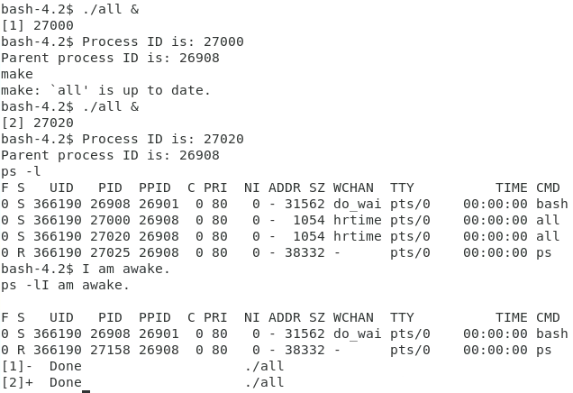
- parent process ID (PPID)
3.1 Output
2pts Repeat this experiment and observe what changes and doesn't change.
Process name: all, all

Process State: S – Interruptible Sleep (waiting for an event to complete)

Process ID: 27000, 27020

Parent Process ID: 26908, 26908
2pts Find out the name of the process that started your programs (the parent). What is it, and what does it do?
Everything stays the same expect for the Process ID.
Bash is responsible for starting the program. Bash is the command processor for the Unix shell.
3.2:
1pt Include the output from the program
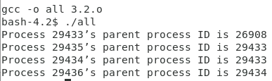

4pts "Draw" the process tree (the nodes should be PIDs)
3pts Explain how the tree was built in terms of the program code
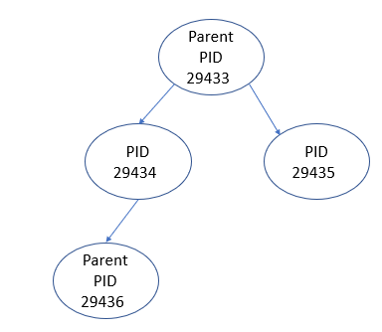
2pts Try the program again without sleep(2). Explain what happens when the sleep statement is removed. You should see processes reporting a parent PID of 1. Redirecting output to a file may interfere with this, and you may need to run the program multiple times to see it happen.
In the output all of the process ID’s are linked to their specific parent process ID’s so I used that to make my process tree.
After removing sleep(2) I found that upon running the program the different processes parent process ID’s returned 1.

3.3:
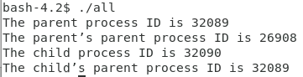
2pts Include the (completed) program and its output
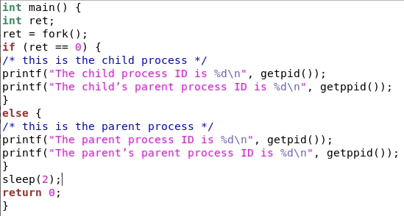
4pts Speculate why it might be useful to have fork return different values to the parent and child. What advantage does returning the child's PID have?
It is useful to have fork return different values to the parent and child because it makes it easier to understand when reading the whole program output. Returning the child’s PID is important because it makes it allows the parent of the child to be easily distinguishable.
3.4:
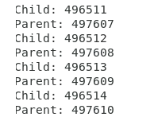
2pts Include small (but relevant) sections of the output

4pts Make some observations about time slicing. Can you find any output that appears to have been cut off? Are there any missing parts? What's going on (mention the kernel scheduler)?
I noticed that the program has a hard time switching from child to parent, cutting some parts of the output out. The scheduler is set to run ponce every time slice and the it switches the processes.

3.5:
6pts Explain the major difference between this experiment and experiment 4.
Be sure to look up what wait does (man 2 wait).
In this experiment the wait(NULL) forces the program to block all parent processes until all the child processes have concluded compared to the experiment 4.
3.6:
2pts The program appears to have an infinite loop. Why does it stop?
4pts From the definitions of sleep and usleep, what do you expect the child's count
It stopped because the KILL function was executed from the else statement due to the child and parent running in parallel.
to be just before it ends?
2pts Why doesn't the child reach this count before it terminates?
I expect the child’s count to be around 990
As the program runs the else condition begins to execute faster so eventually the Kill function kills the child process that is running.

3.7:
8pts Read the man page for execl and relatives (man 3 exec). Under what conditions is the printf statement executed? Why isn't it always executed?
(consider what would happen if you changed the program to execute something other than /bin/ls.)
The printf will execute if execl does not exist. Conversely, if execl is called first the printf would not execute because the execl command replaces the current process image with a new one.
3.8:
2pts What is the range of possible exit status values printed for the child process?
2pts What is the signal value the child process uses to terminate itself, as determined and printed by the parent process?
The range of possible exit status values printed for the child process is 0 to 255.

2pts When do you think the return value of main() would be useful?

Hint: look at the commands true and false.
The return value is useful to determine the way a child’s process is terminated.

